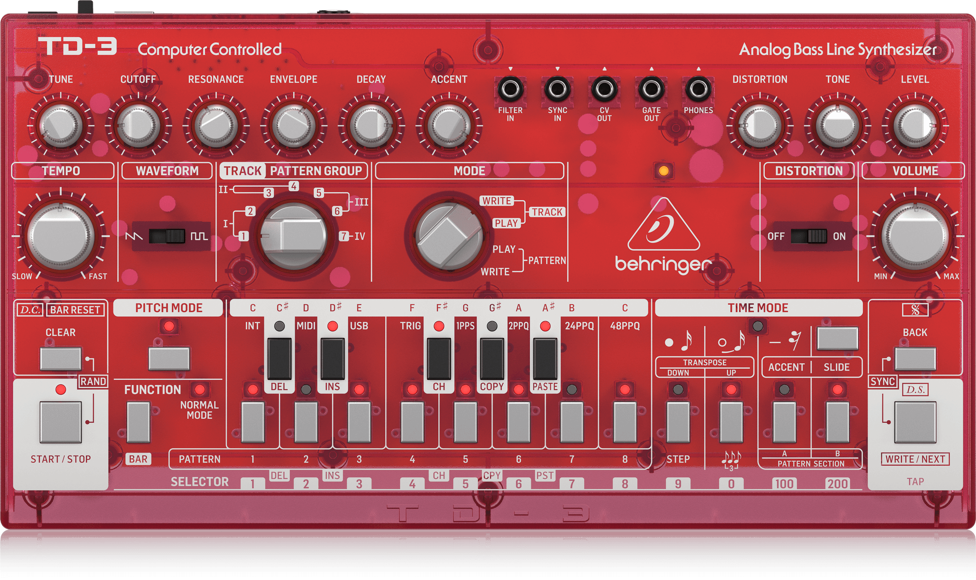

**Clear a pattern**

1. Switch to (PWM)
2. choose PG you wish to erase
3. [h]+(CLEAR)
4. [p]+(1-8) -> in pattern section A and/or B
5. [r]-(CLEAR)
6. Check pattern by [h]+(SS) + (1-8)

**Copy a Pattern**

1. Select the pattern you want to copy
2. [h]+(F) -> [p]+(COPY) -> [r]-(F)
3. [p]+(1-8) where you want to copy to
4. [h]+(F) -> [p]+(PASTE) -> [r]-(F)

**Construct a song**

Set to Track Write Mode (TWM)

1. [p]+(CLR) -> in order to ‘bar rest’

To set the pattern order:

1. [p]+(SS) + select desired pattern (1-8)
2. OPTIONAL:

[p]+(PM) + a key to transpose

1. [p]+(W/N)

**Midi Sync**

1. [p] (BACK) + (W/N)
2. Select: (INT)/(MIDI)/(USB)/(TRIG)
3. Select: (1PPS) – (28PPQ)

**In this guide:**

[p] = press (default is 1x)

[h]+ = hold

[r]- = release

(BUTTON X) = button X

/ = or

(CLR) = CLEAR button

(SS) = Start/Stop button

(1-8) = Button 1 through 8

(F) = Function button

(PM) = Pitch Mode button

(TM) = Time Mode button

(W/N) = Write / Next button

**Abbreviations**

Pattern = PA

Pattern Group = PG

Pattern Section (A / B) = PS(-A/B)

Track = TR

Pattern Play Mode = PPM

Pattern Write Mode = PWM

Track Play Mode = TPM

Track Write Mode = TWM

**System overview**

4 PG

16 PA per PG

7 Tracks:

PG I consist of TR 1+2

PG II consist of TR 3+4

PG III consist of TR 5+6

PG IV consist of TR 7

**Build a pattern in (PWM)**

Default number of steps in a new/ clear Pattern = 16

**A. Set the number of steps (1-16 steps) - OPTIONAL**

1. [h]+(F)
2. [p]+ (STEP) x number of desired steps (it only registers the 1st 16 inputs)
3. [r]-(F)

* **Number of steps is set now.**

**B. Insert notes:**

1. [p]+(PITCH MODE)
2. Play desired notes on keyboard –> limited to #steps set in A
3. [p] (F) to exit pitch mode

* **Steps are notes now.**

**C. Put effects on steps – Accent / Slide / Transpose:**

1. [p]+(PM)
2. [h]+(W/N) {you hear this note playing} + a combination of (DOWN) (UP) (ACCENT) (SLIDE)
3. Now your 1st step/note is altered. **Repeat** previous step **for all available steps/notes:**
4. [h]+(W/N) + a combination of (DOWN) (UP) (ACCENT) (SLIDE)
5. [h]+(W/N) + a combination of (DOWN) (UP) (ACCENT) (SLIDE)
6. Etc. it will end automatically when you reach your final step (max 16)
7. [p] (F) to exit pitch mode

* **Each step has an effect (or is un-altered)**

**D. ‘Load’ the notes by allocating either a step (•), tie (ο) or rest (-)**

1. [p]+(TIME MODE)
2. Press (•) or (ο) or (-) in sequence and as many times as there are steps (default 16)

For example: (•) (•) (•) (•) (ο) (-) (•) (•) (•) (•) (ο) (-) (•) (•) (•) (•) for a 16 step seq.

1. [p] (F) to exit pitch mode and [p]+(SS) to play the finalized sequence

* **The pattern is finished now!**

